**ASSIGNMENT**

**MODULE 4**

**ELB**

**DONE BY**

**RANJITH KUMAR**

**Tasks To Be Performed:**

1. Create a Classic Load Balancer and register 3 EC2 instances with different

web pages running in them.

2. Migrate the Classic Load Balancer into an Application Load Balancer.

STEP 1 : Open AWS

STEP 2 : In services select EC2

STEP 3 : Click instance and click launch instances

STEP 4 : In launch a instance page under summary select number of instance:3

STEP 5 : Now give name , select AMI , instance type , keypair , network settings , storage for our instances

STEP 6 : For updating and installing apache in our server codes is given in advanced details section

STEP 7 : Click launch instance

STEP 8 : Now connect the 1st EC2 instance and give the necccesary instruction to show in the web server

STEP 9 : Repeat same for other 2 instances

STEP 10 : 3 different web pages are running

STEP 11 : Now select Load balancers > Create Load Balancers

STEP 12 : Select classic load balancer

STEP 13 : Key the name , network , security groups , mapping , instances

STEP 14 : Created Classic load balancer

**“ Migration of classic load balancer to application load balancer option not available for me . So created till Load balancer in the task ”**

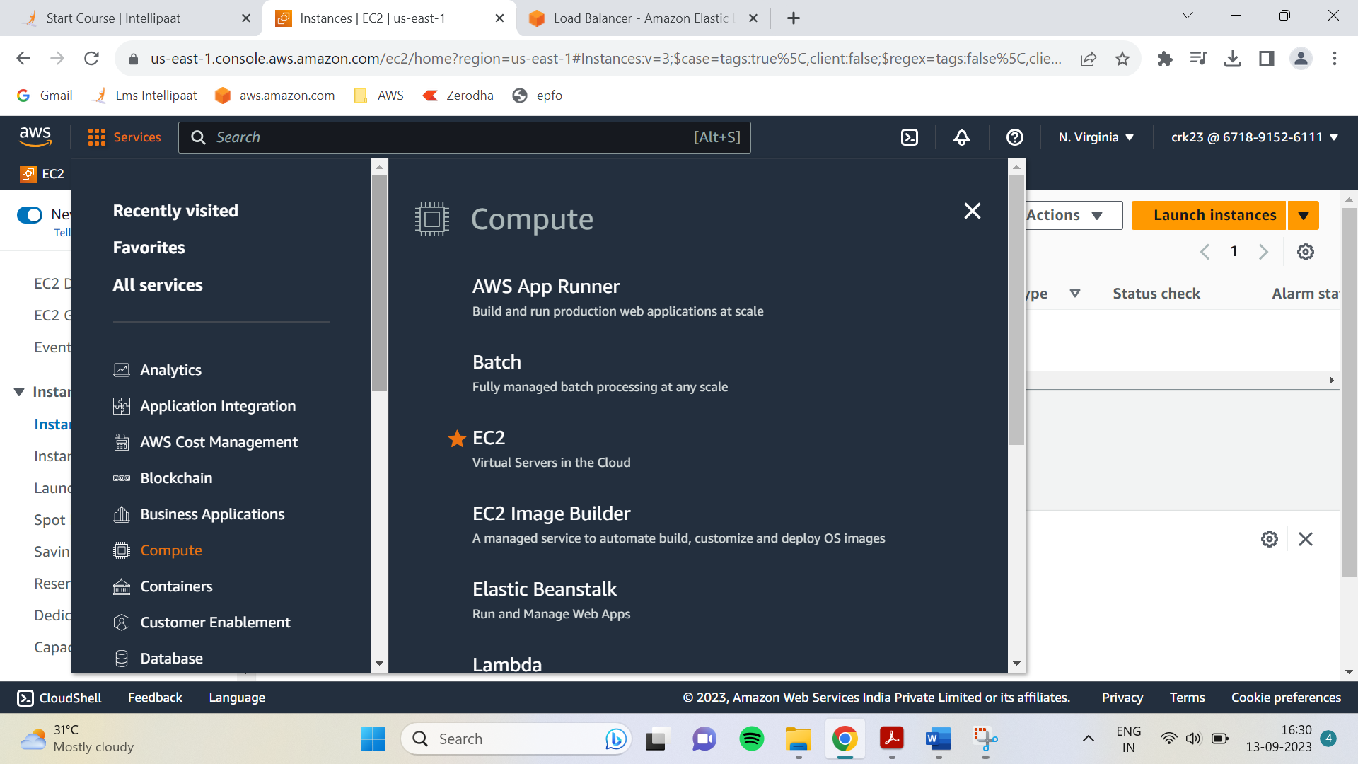

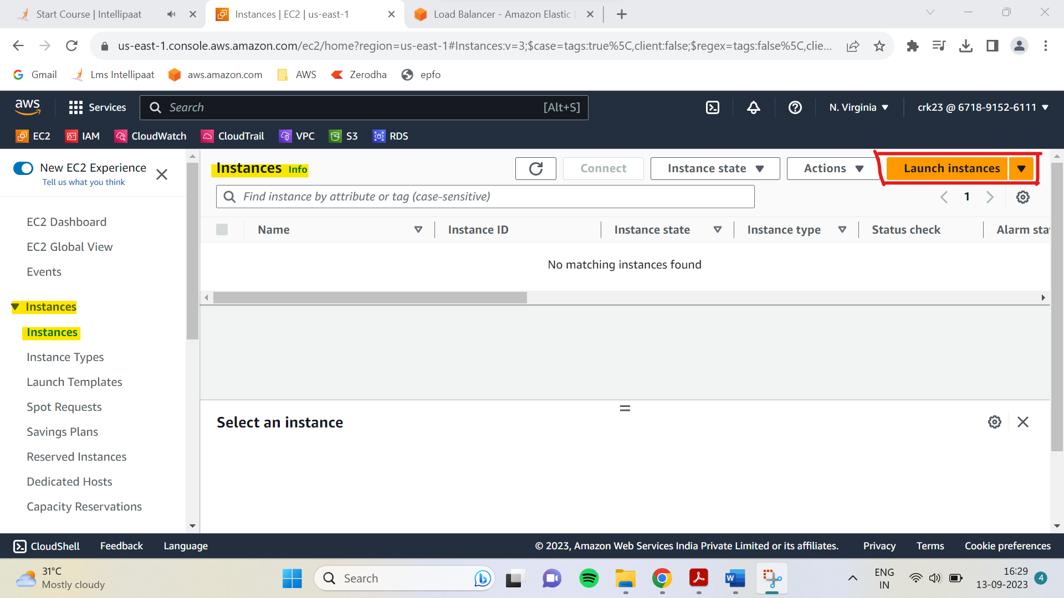

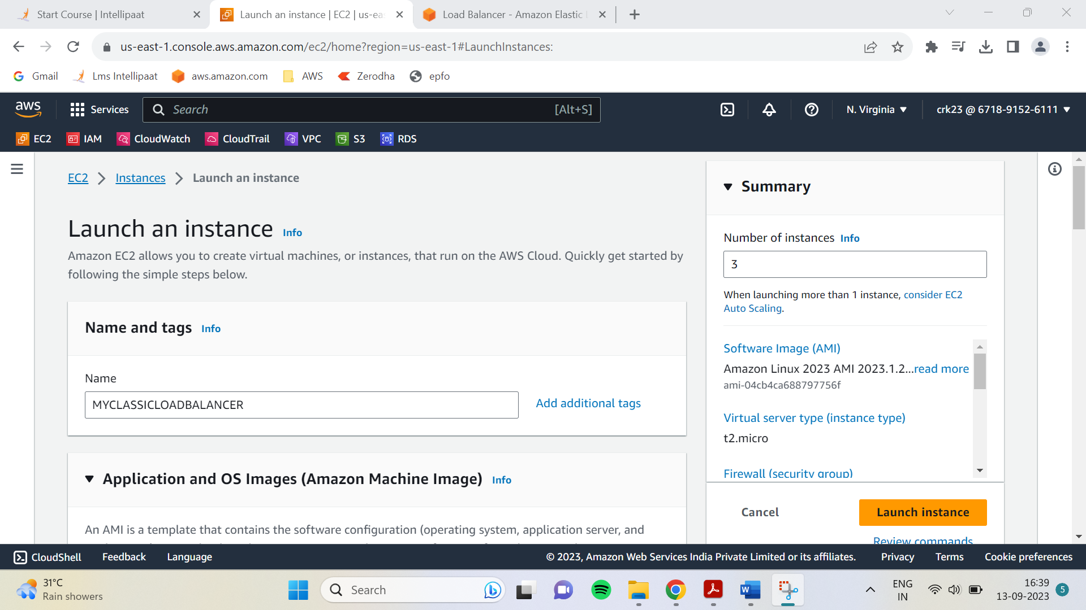

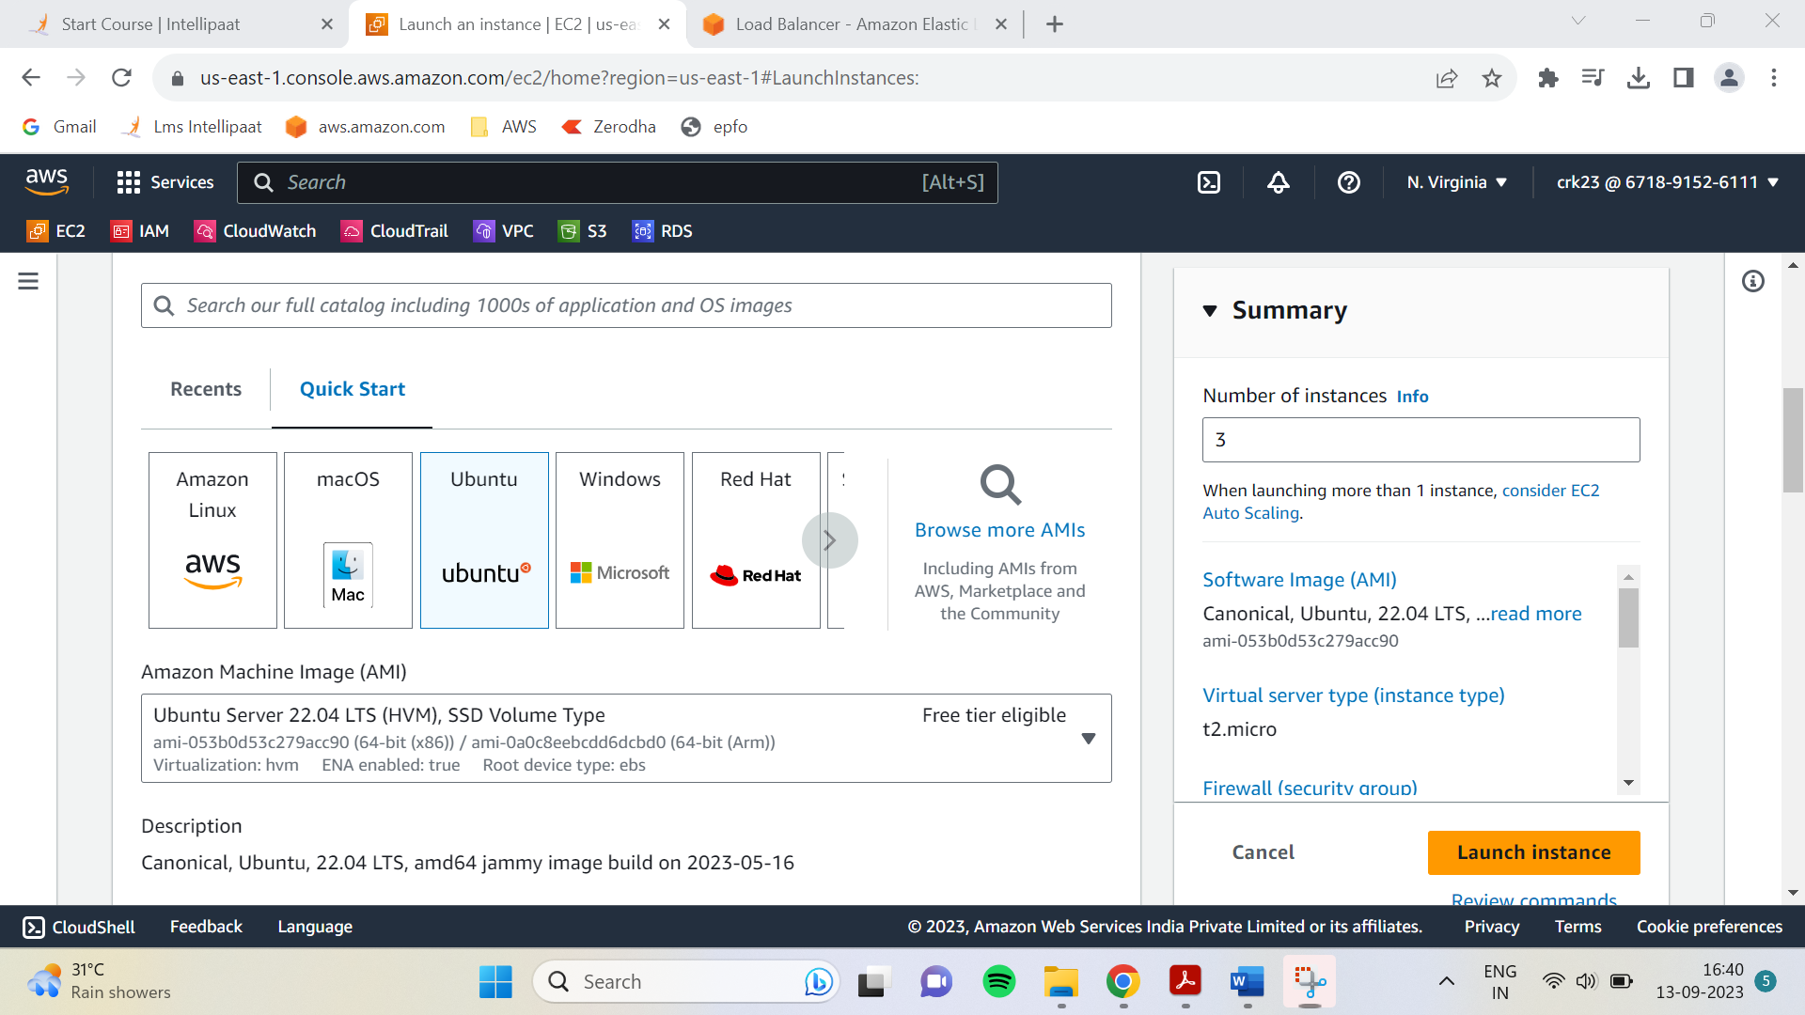

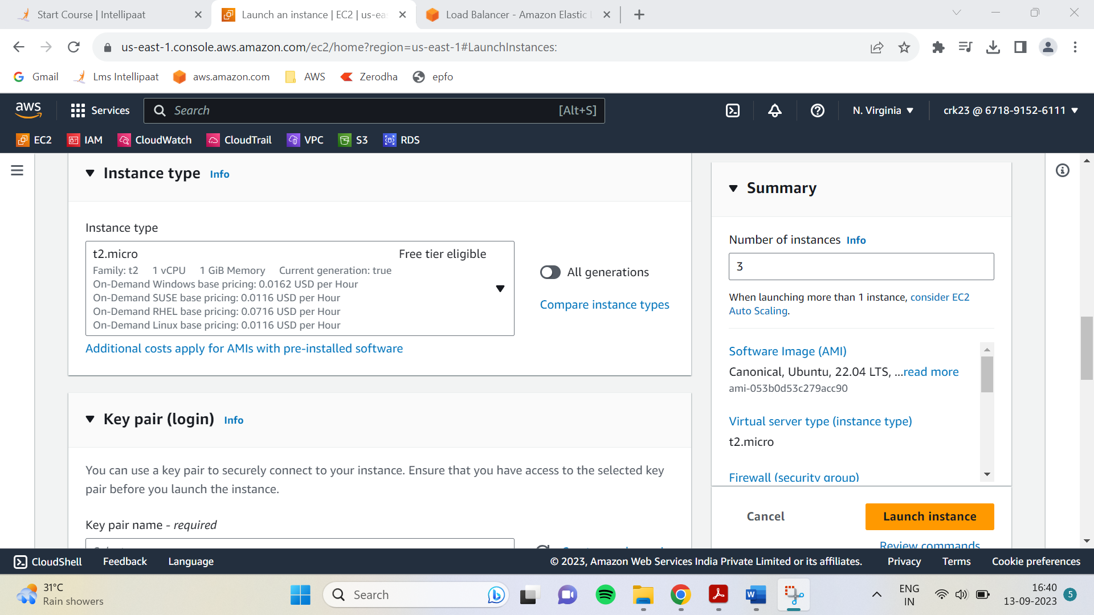

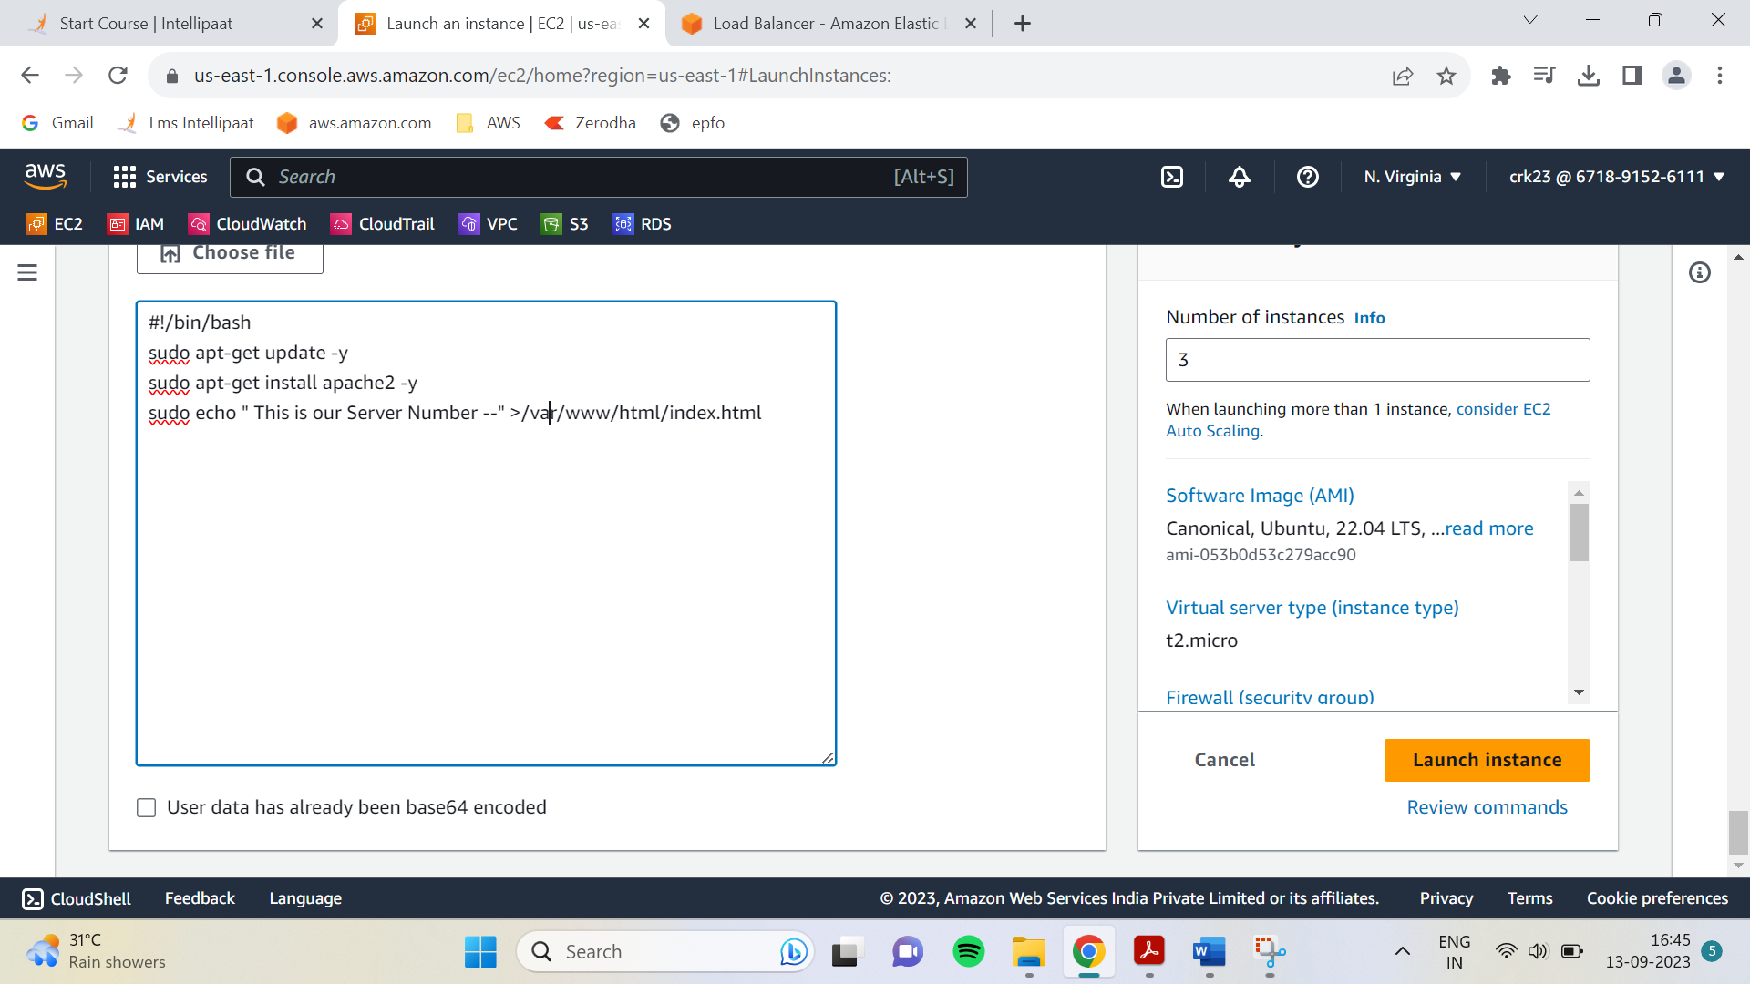

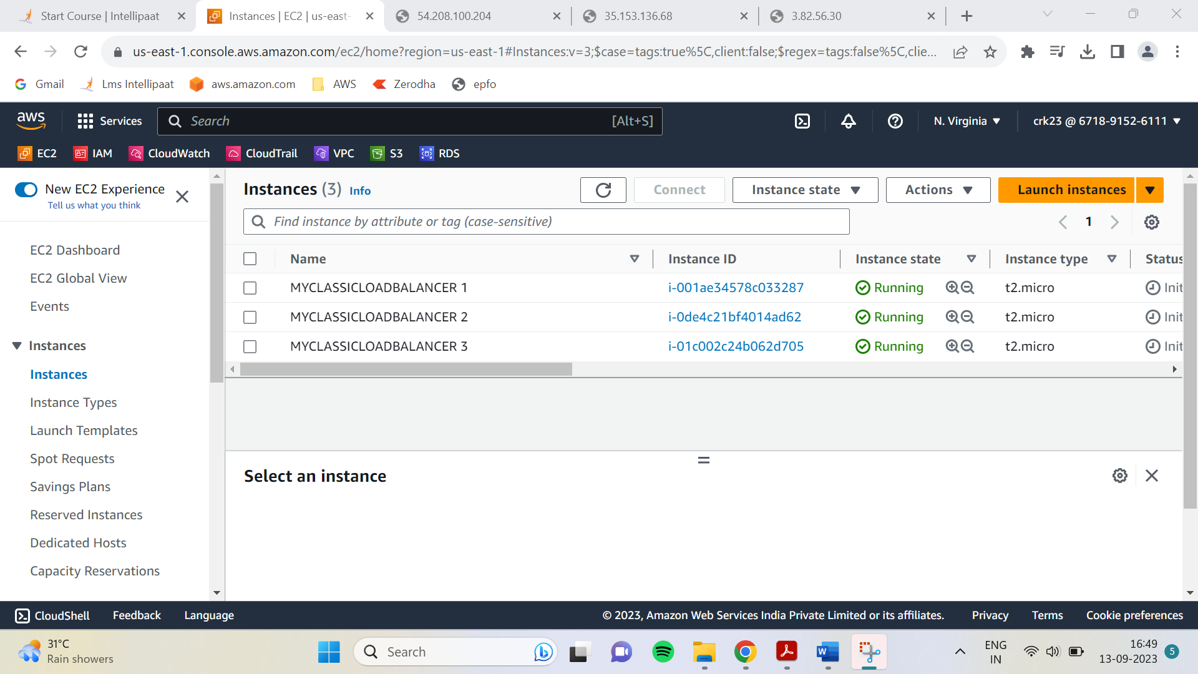

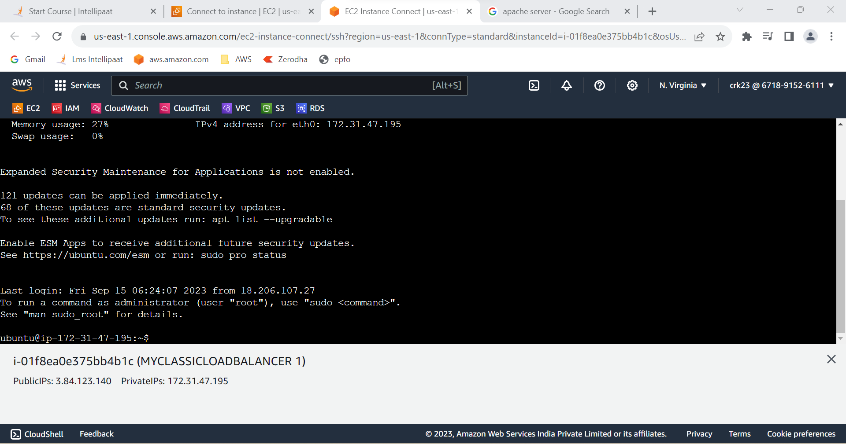

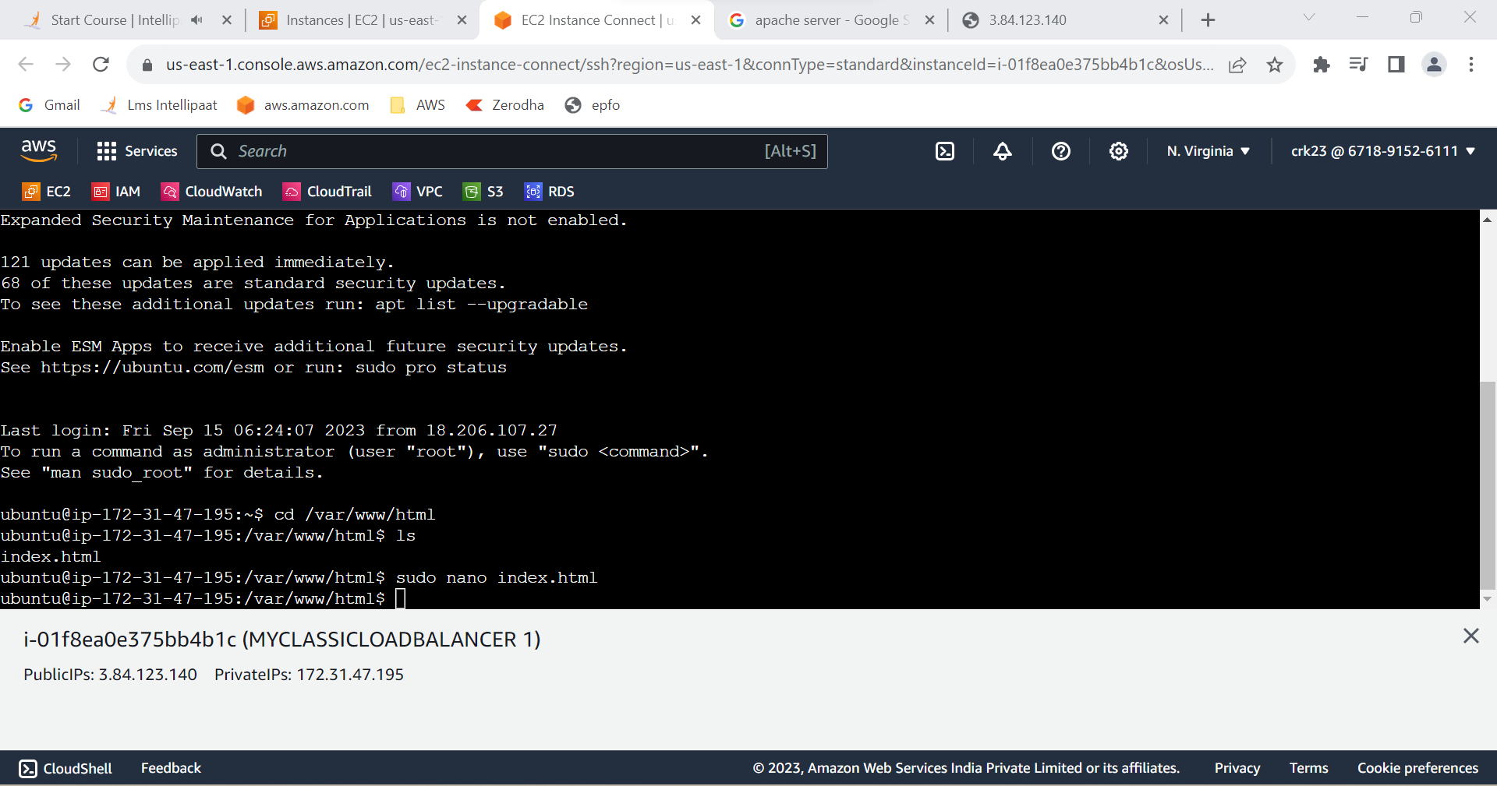

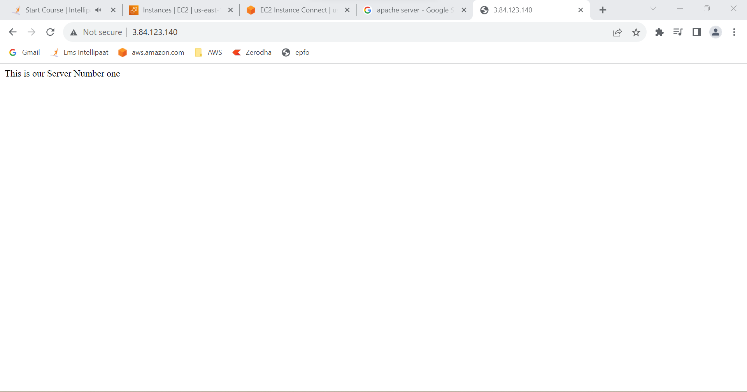

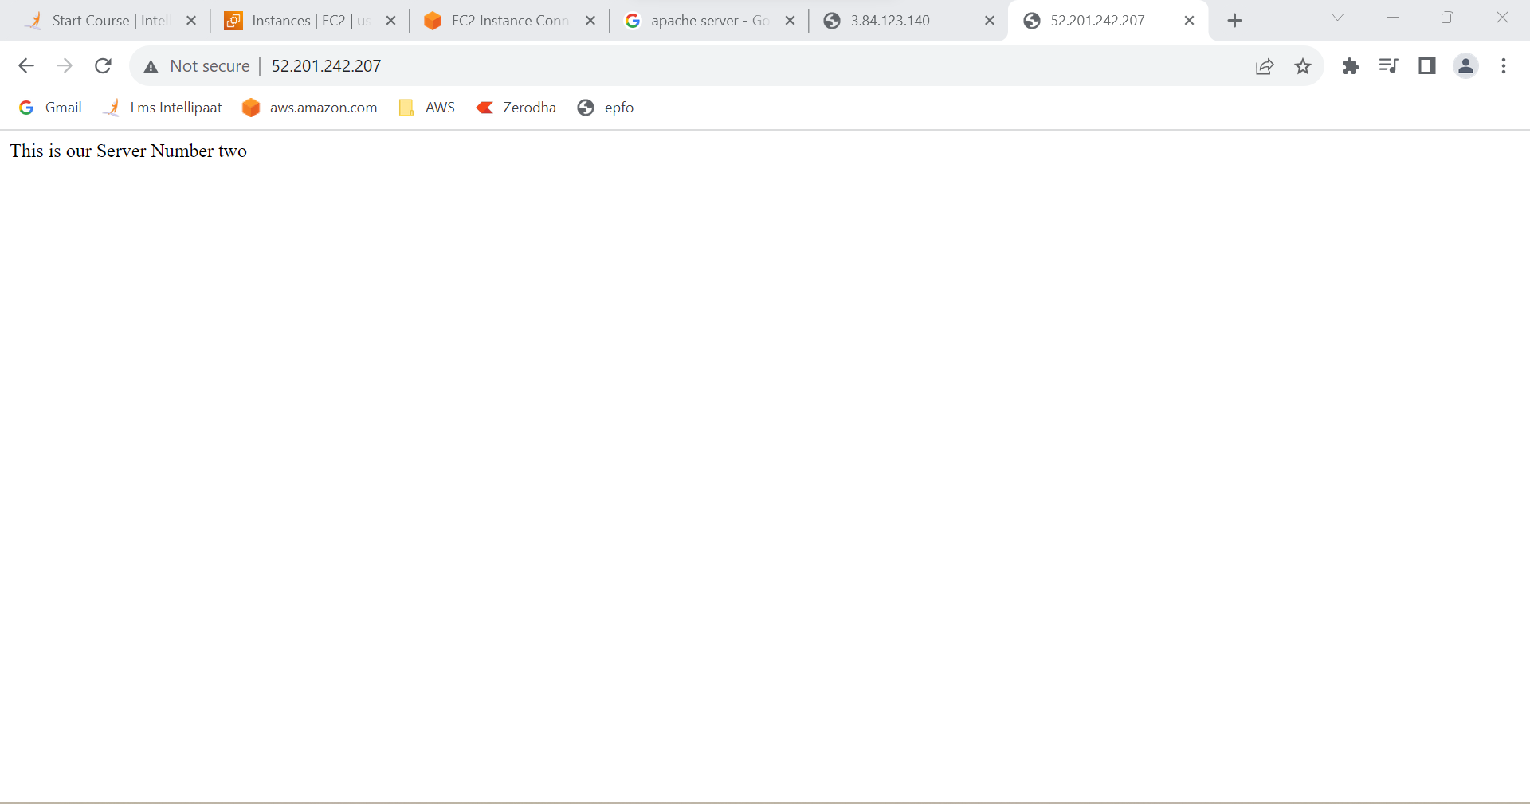

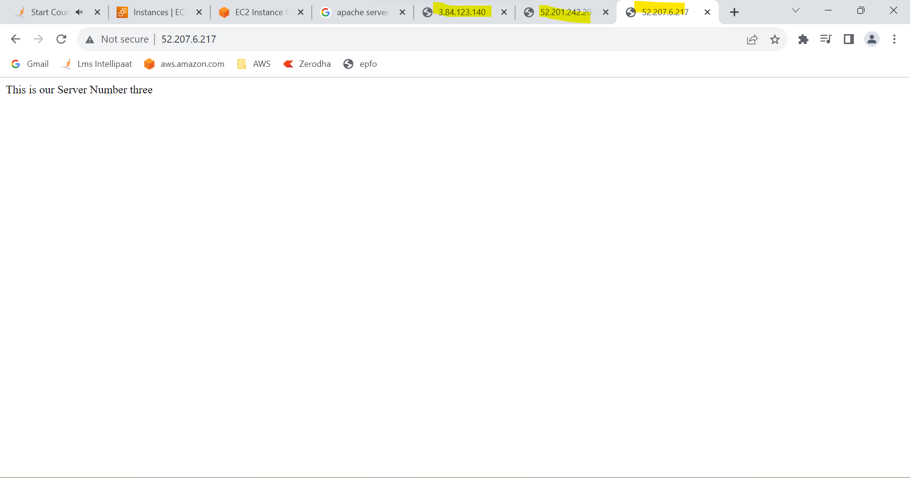

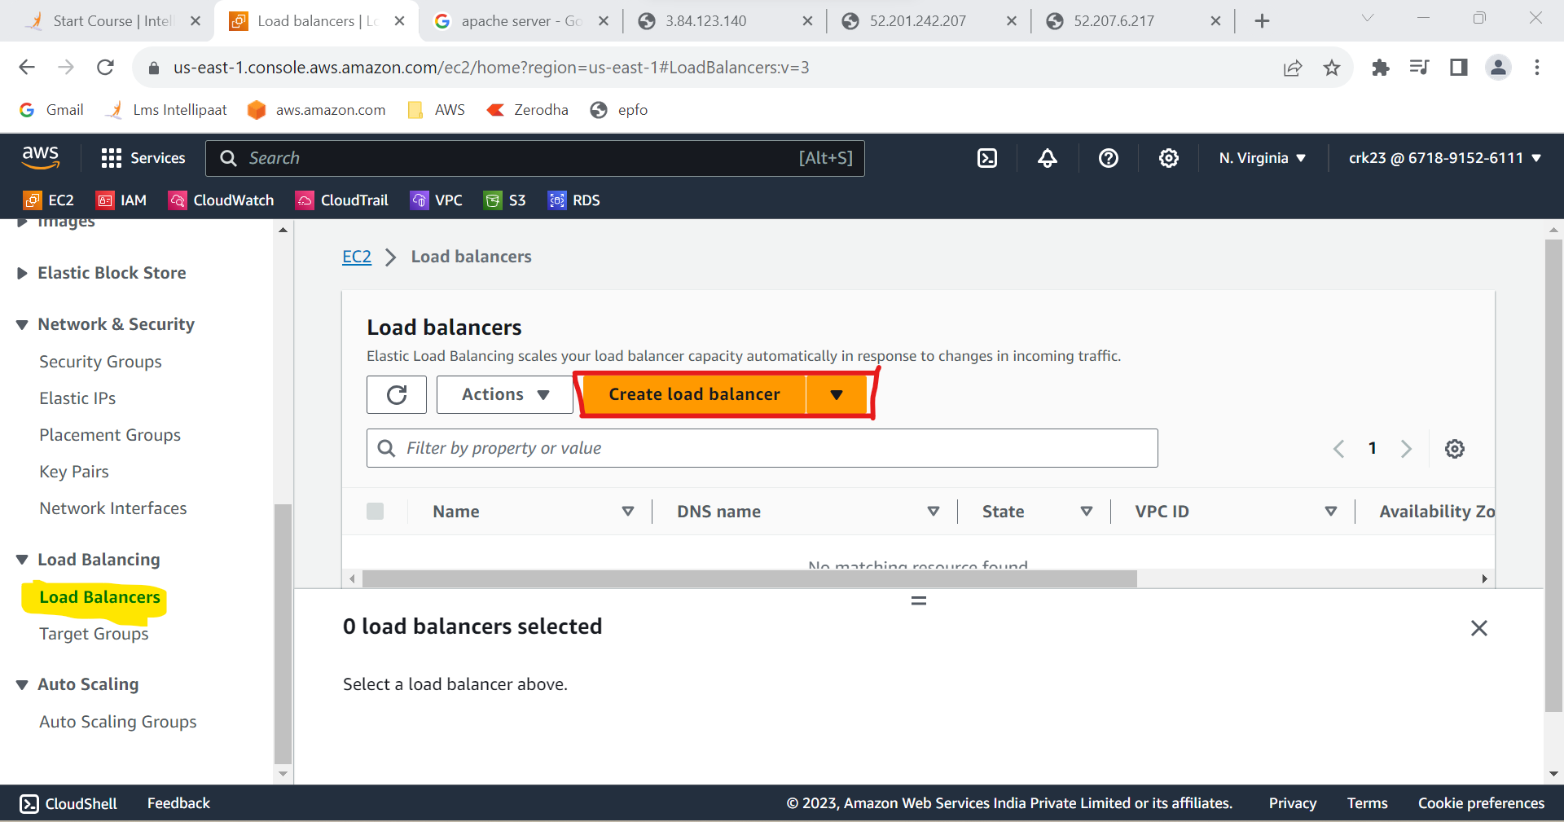

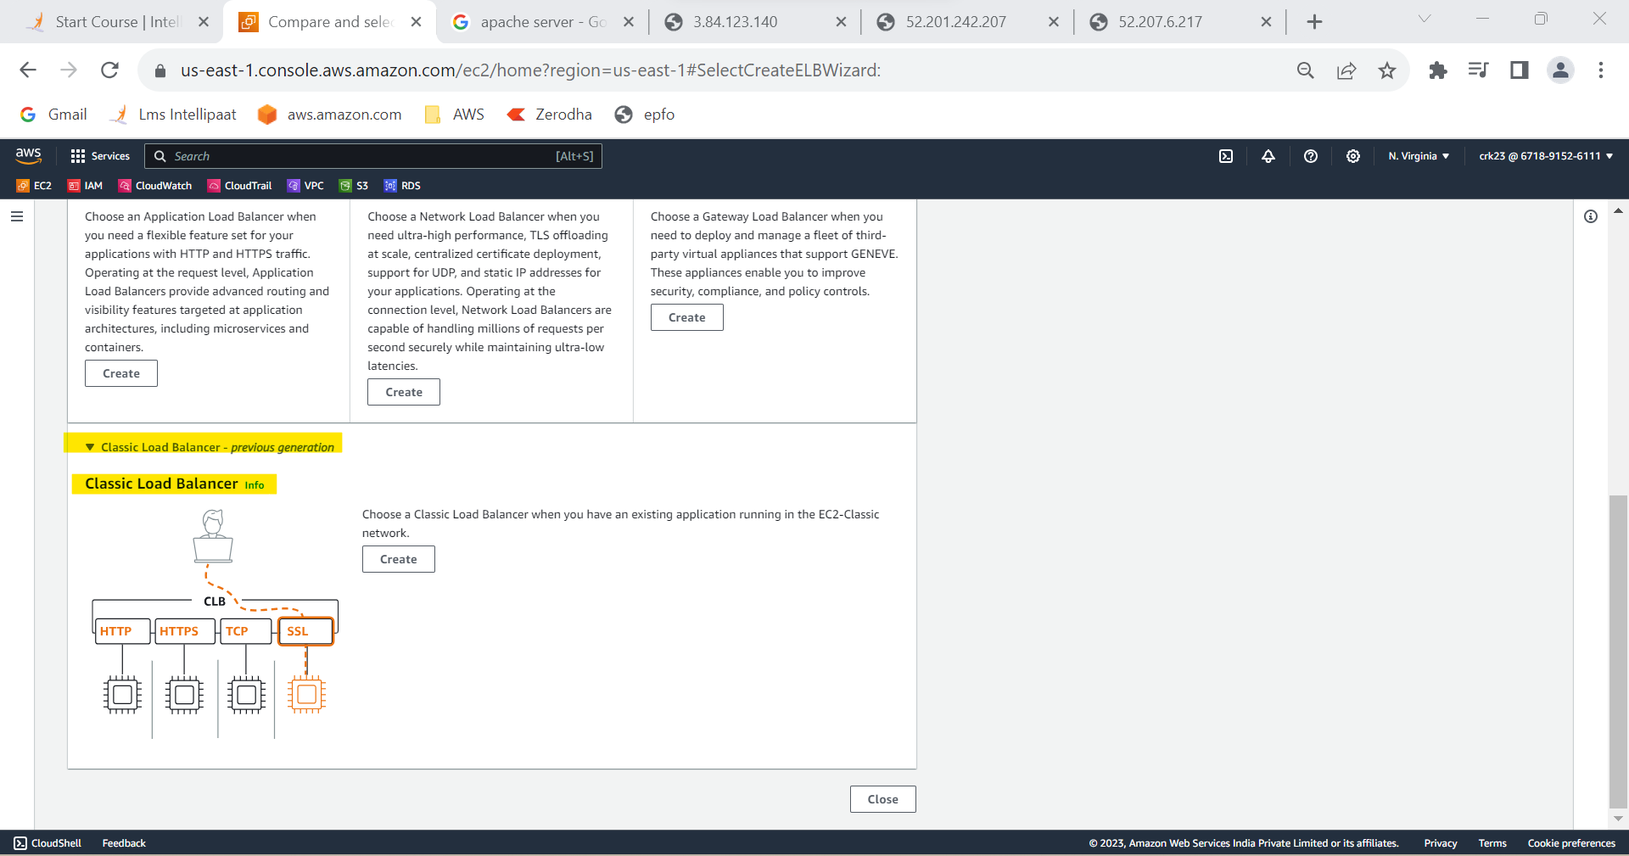

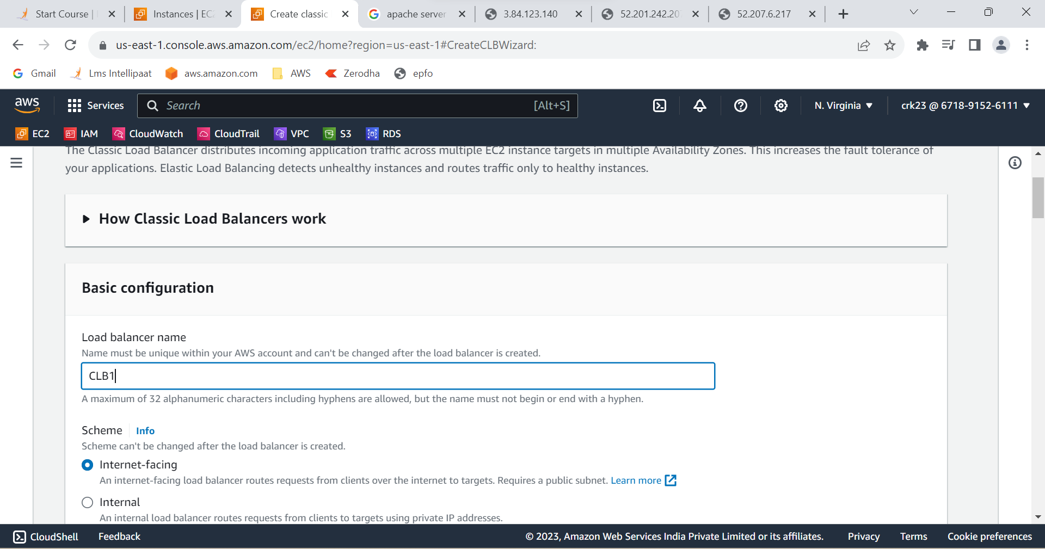

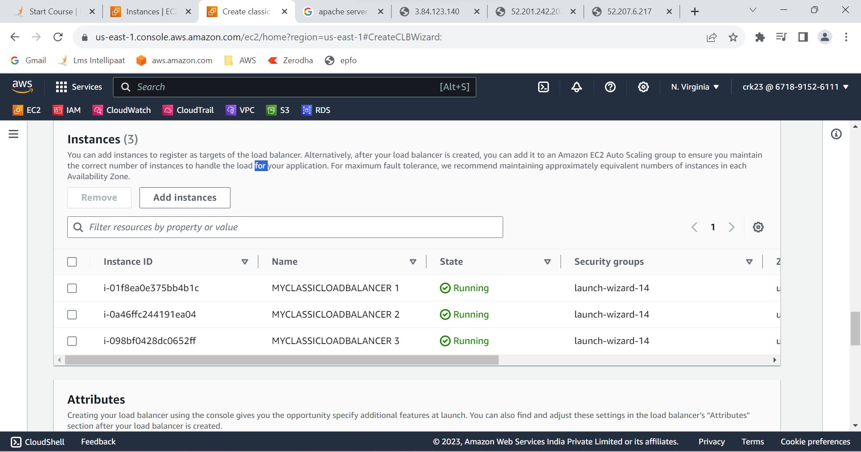

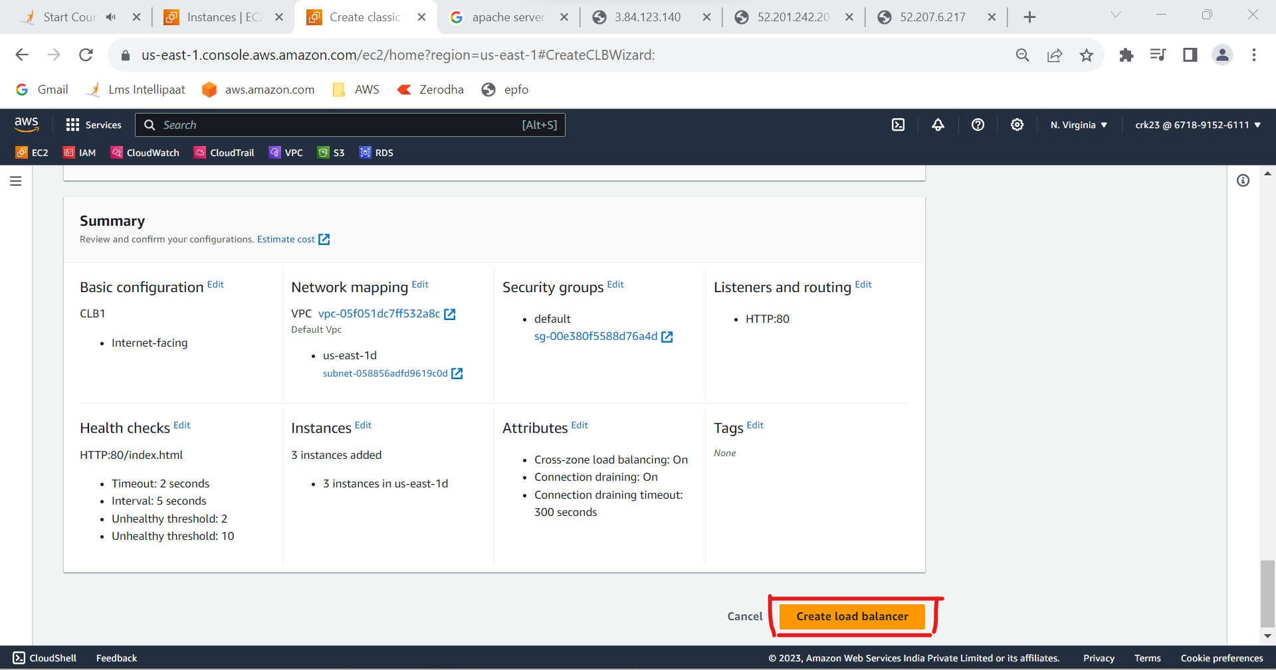

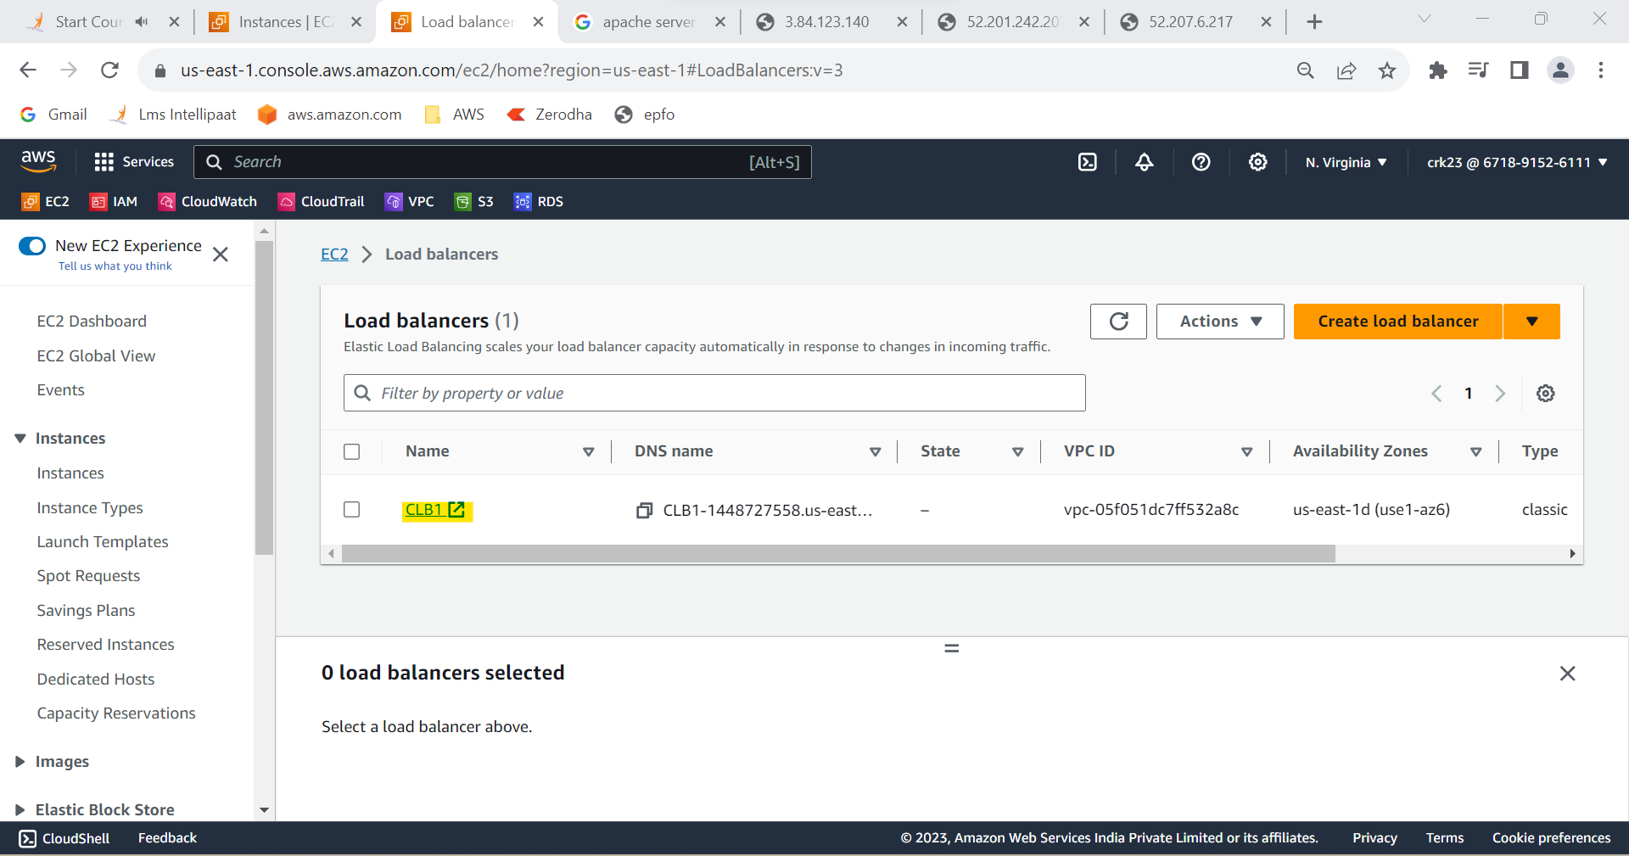

**Output:**

Created a Classic Load Balancer and register 3 EC2 instances with different web pages running in them.

**“ Migration of classic load balancer to application load balancer option not available for me . So created till Load balancer in the task ”**